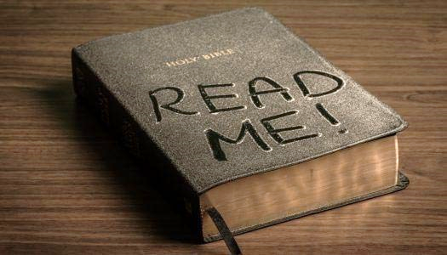
2021 BIBLE READING CHALLENGE
Read the Bible straight through from Genesis to Revelation
JULY

__ July 1 – Psalm 90-95

__ July 2 – Psalm 96-102

__ July 3 – Psalm 103-105

__ July 4 – Psalm 106-107

__ July 5 – Psalm 108-114

__ July 6 – Psalm 115-118

__ July 7 – Psalm 119.1-88

__ July 8 – Psalm 119.89-176

__ July 9 – Psalm 120-132

__ July 10 – Psalm 133-139

__ July 11 – Psalm 140-145

__ July 12 – Proverbs 1-3

__ July 13 – Proverbs 4-6

__ July 14 – Proverbs 7-9

__ July 15 – Proverbs 10-12

__ July 16 – Proverbs 13-15

__ July 17 – Proverbs 13-15

__ July 18 – Proverbs 16-18

__ July 19 – Proverbs 19-21

__ July 20 – Proverbs 22-23

__ July 21 – Proverbs 24-26

__ July 22 – Proverbs 27-29

__ July 23 – Proverbs 30-31

__ July 24 – Ecclesiastes 1-4

__ July 25 – Ecclesiastes 5-8

__ July 26 – Ecclesiastes 9-12

__ July 27 – Song of Solomon 1-8

__ July 28 – Isaiah 1-4

__ July 29 – Isaiah 5-8

__ July 30 – Isaiah 9-12

__ July 31 – Isaiah 13-17

