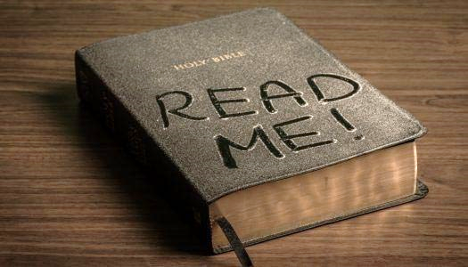
2021 BIBLE READING CHALLENGE
Read the Bible straight through from Genesis to Revelation

JANUARY

__ January 1 – Genesis 1-3

__ January 2 – Genesis 4-7

__ January 3 – Genesis 8-11

__ January 4 – Genesis 12-15

__ January 5 – Genesis 16-18

__ January 6 – Genesis 19-21

__ January 7 – Genesis 22-24

__ January 8 – Genesis 25-26

__ January 9 – Genesis 27-29

__ January 10 – Genesis 30-31

__ January 11 – Genesis 32-34

__ January 12 – Genesis 35-37

__ January 13 – Genesis 38-40

__ January 14 – Genesis 41-42

__ January 15 – Genesis 43-45

__ January 16 – Genesis 46-47

__ January 17 – Genesis 48-50

__ January 18 – Exodus 1-3

__ January 19 – Exodus 4-6

__ January 20 – Exodus 7-9

__ January 21 – Exodus 10-12

__ January 22 – Exodus 13-15

__ January 23 – Exodus 16-18

__ January 24 – Exodus 19-21

__ January 25 – Exodus 22-24

__ January 26 – Exodus 25-27

__ January 27 – Exodus 28-29

__ January 28 – Exodus 30-32

__ January 29 – Exodus 33-35

__ January 30 – Exodus 36-38

__ January 31 – Exodus 39-40

