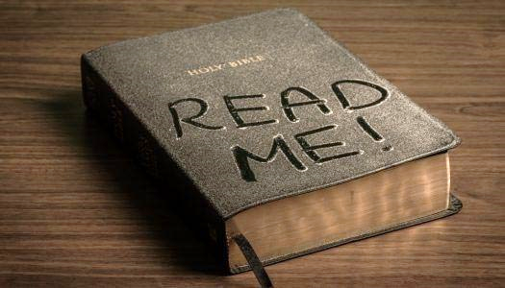
2021 BIBLE READING CHALLENGE
Read the Bible straight through from Genesis to Revelation
DECEMBER

__ Dec. 1 – 1 Corinthians 9-11

__ Dec. 2 – 1 Corinthians 12-14

__ Dec. 3 – 1 Corinthians 15-16

__ Dec. 4 – 2 Corinthians 1-4

__ Dec. 5 – 2 Corinthians 5-9

__ Dec. 6 – 2 Corinthians 10-13

__ Dec. 7 – Galatians 1-3

__ Dec. 8 – Galatians 4-6

__ Dec. 9 – Ephesians 1-3

__ Dec. 10 – Ephesians 4-6

__ Dec. 11 – Philippians 1-4

__ Dec. 12 – Colossians 1-4

__ Dec. 13 – 1 Thessalonians 1-5

__ Dec. 14 – 2 Thessalonians 1-3

__ Dec. 15 – 1 Timothy 1-6

__ Dec. 16 – 2 Timothy 1-4

__ Dec. 17 – Titus 1-3, Philemon 1

__ Dec. 18 – Hebrews 1-6

__ Dec. 19 – Hebrews 7-10

__ Dec. 20 – Hebrews 11-13

__ Dec. 21 – James 1-5

__ Dec. 22 – 1 Peter 1-5

__ Dec. 23 – 2 Peter 1-3

__ Dec. 24 – 1 John 1-5

__ Dec. 25 – 2 John 1, 3 John 1, Jude 1

__ Dec. 26 – Revelation 1-3

__ Dec. 27 – Revelation 4-8

__ Dec. 28 – Revelation 9-12

__ Dec. 29 – Revelation 13-16

__ Dec. 30 – Revelation 17-19

__ Dec. 31 – Revelation 20-22

