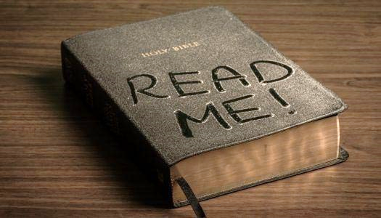
2021 BIBLE READING CHALLENGE
Read the Bible straight through from Genesis to Revelation
NOVEMBER

__ Nov. 1 – Luke 19.20

__ Nov. 2 – Luke 21-22

__ Nov. 3 – Luke 23-24

__ Nov. 4 – John 1-2

__ Nov. 5 – John 3-4

__ Nov. 6 – John 5-6

__ Nov. 7 – John 7-8

__ Nov. 8 – John 9-10

__ Nov. 9 – John 11-12

__ Nov. 10 – John 13-15

__ Nov. 11 – John 16-18

__ Nov. 12 – John 19-21

__ Nov. 13 – Acts 1-3

__ Nov. 14 – Acts 4-6

__ Nov. 15 – Acts 7-8

__ Nov. 16 – Acts 9-10

__ Nov. 17 – Acts 11-13

__ Nov. 18 – Acts 14-15

__ Nov. 19 – Acts 16-17

__ Nov. 20 – Acts 18-20

__ Nov. 21 – Acts 21-23

__ Nov. 22 – Acts 24-26

__ Nov. 23 – Acts 27-28

__ Nov. 24 – Romans 1-3

__ Nov. 25 – Romans 4-7

__ Nov. 26 – Romans 8-10

__ Nov. 27 – Romans 11-13

__ Nov. 28 – Romans 14-16

__ Nov. 29 – 1 Corinthians 1-4

__ Nov. 30 – 1 Corinthians 5-8

